- What is the half-acceptance angle for a large-core step-index fiber with core index of 1.5 and cladding index of 1.495?
- 4.7º
- 7.0º
- 9.4º
- 11º
- 14º
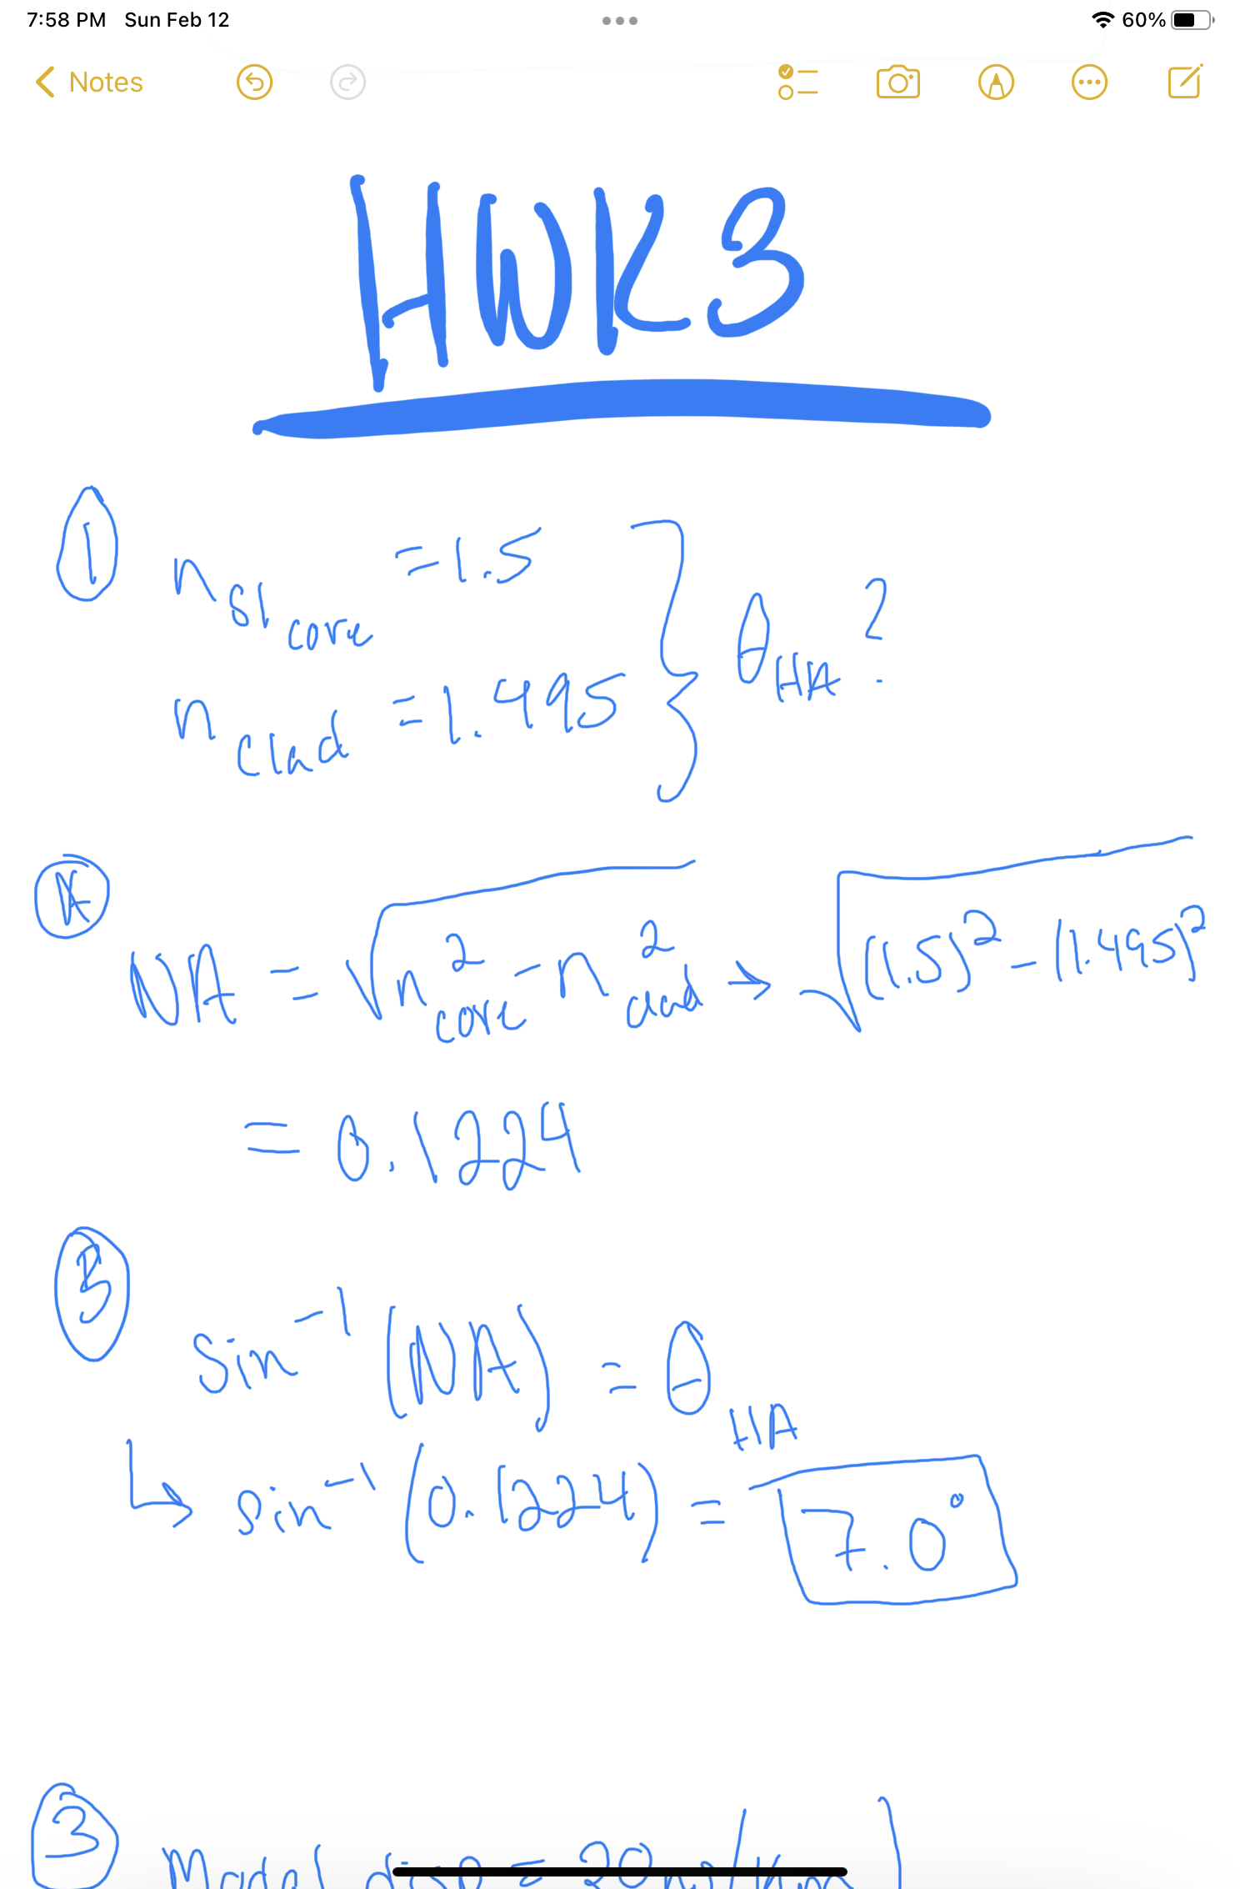
- Modal dispersion is largest in what type of fiber?
- Step-index multimode
- Graded-index multimode
- Step-index single-mode
- Dispersion-shifted single-mode
- polarization-maintaining
3. A fiber has modal dispersion of 20 ns/km. If an instantaneous light pulse traveled
through 8 km of such fiber, what would the pulse length be at the end?
- 8 ns
- 20 ns
- 40 ns
- 80 ns
- 160 ns
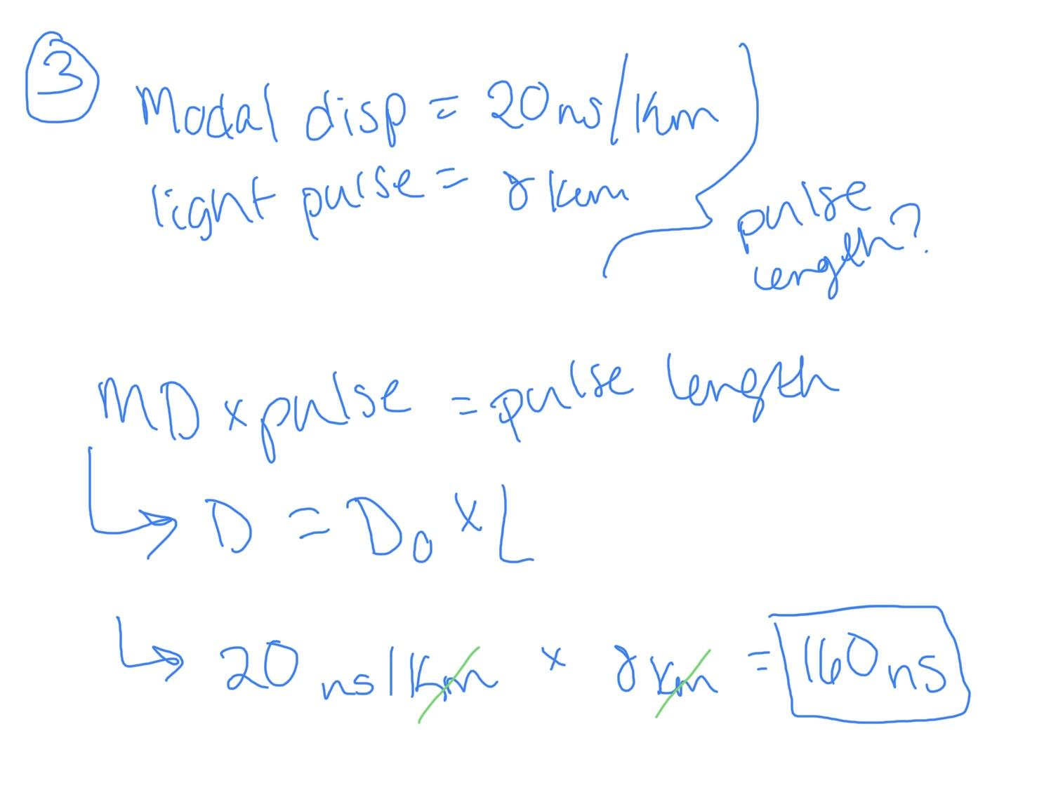
4. What is the maximum data rate that the 8 km length of fiber in #3 would carry?
- 160 Mbit/s
- 20 Mbit/s
- 16 Mbit/s
- 6 Mbit/s
- 4.4 Mbit/s
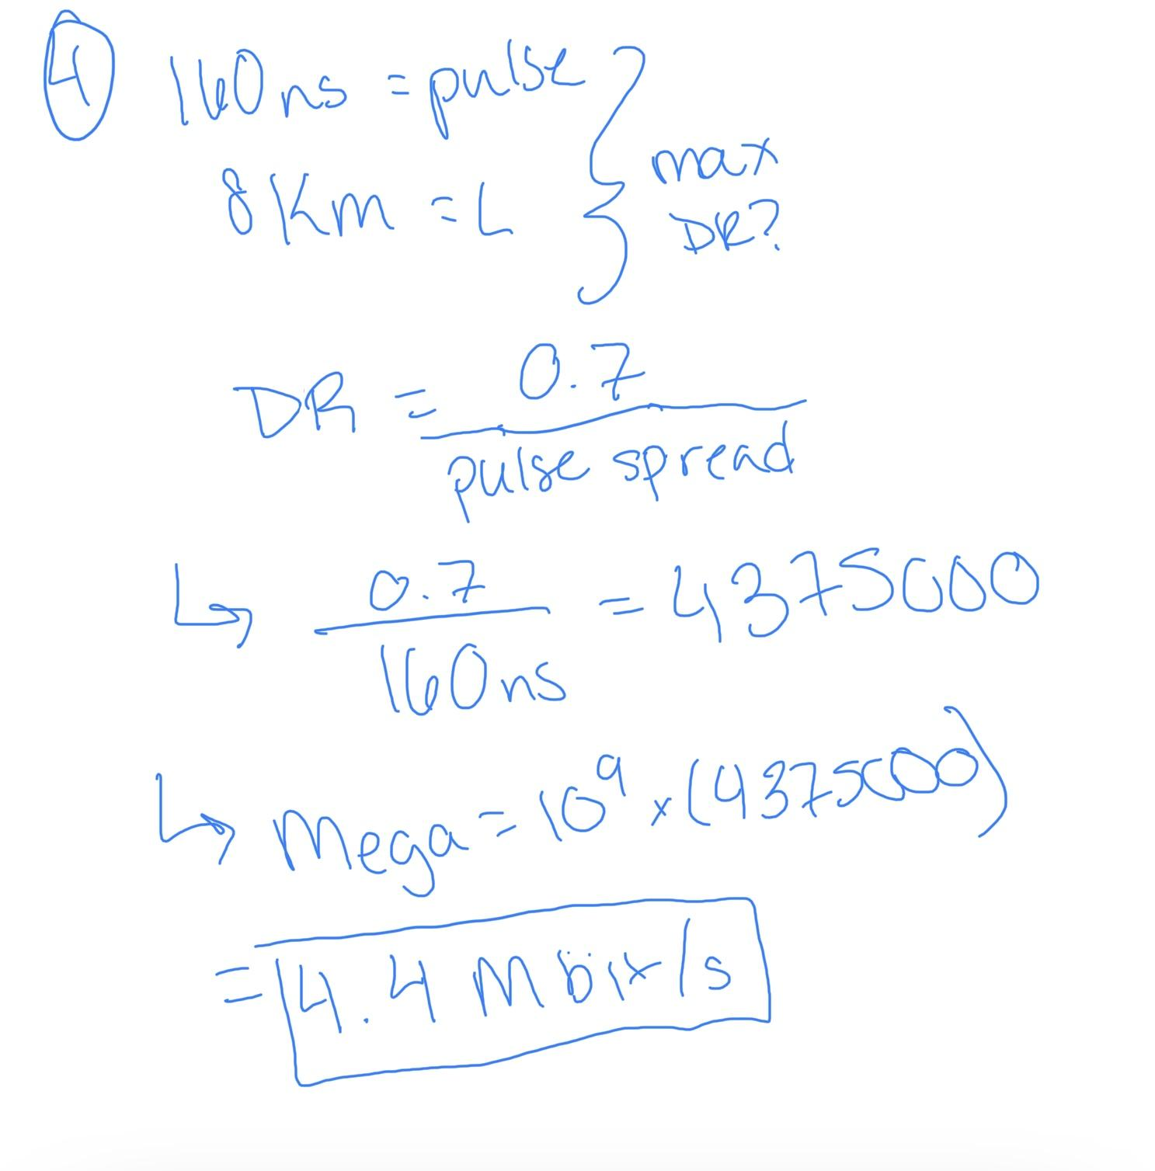
5. What guides light in multimode graded-index fibers?
- Total internal reflection
- Mode confinement in the cladding
- Refraction in the region where core index decreases to match the cladding index
- The optics that couple light into the fiber
6. What is the maximum allowable core diameter for a step-index single-mode fiber
operating at 1.3 micrometers, with core index of 1.5 and cladding index of air?
- 0.34 micrometers
- 0.89 micrometers
- 3.0 micrometers
- 4.8 micrometers
- 5.5 micrometers
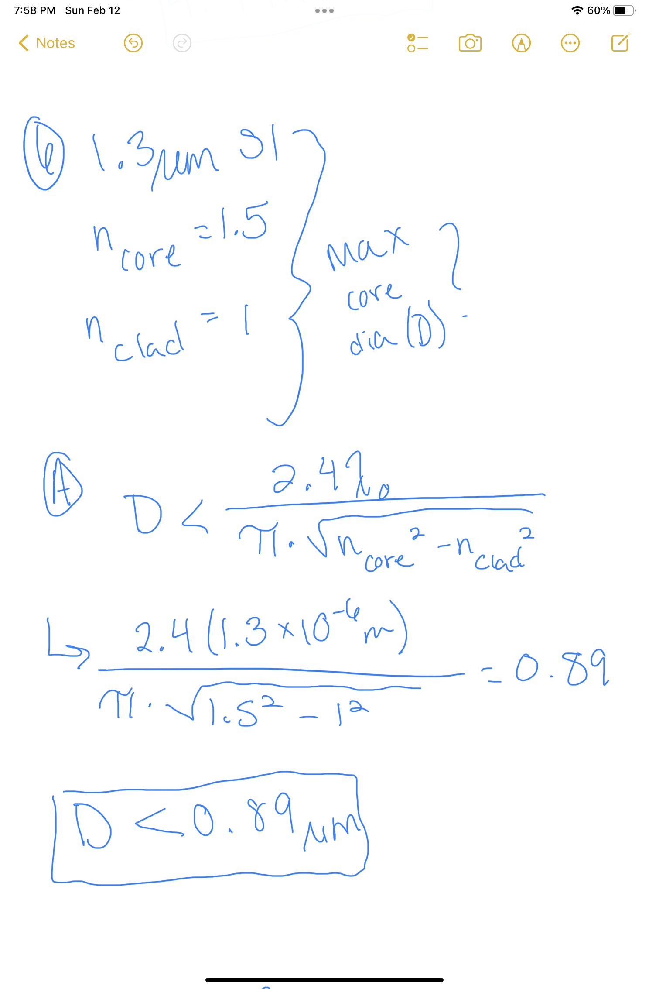
7. What is the maximum core diameter for a step-index single-mode fiber operating
at 1.3 micrometers, with core index of 1.5 and cladding index of 1.495?
- 0.89 micrometers
- 3.0 micrometers
- 4.1 micrometers
- 8.1 micrometers
- 10.1 micrometers
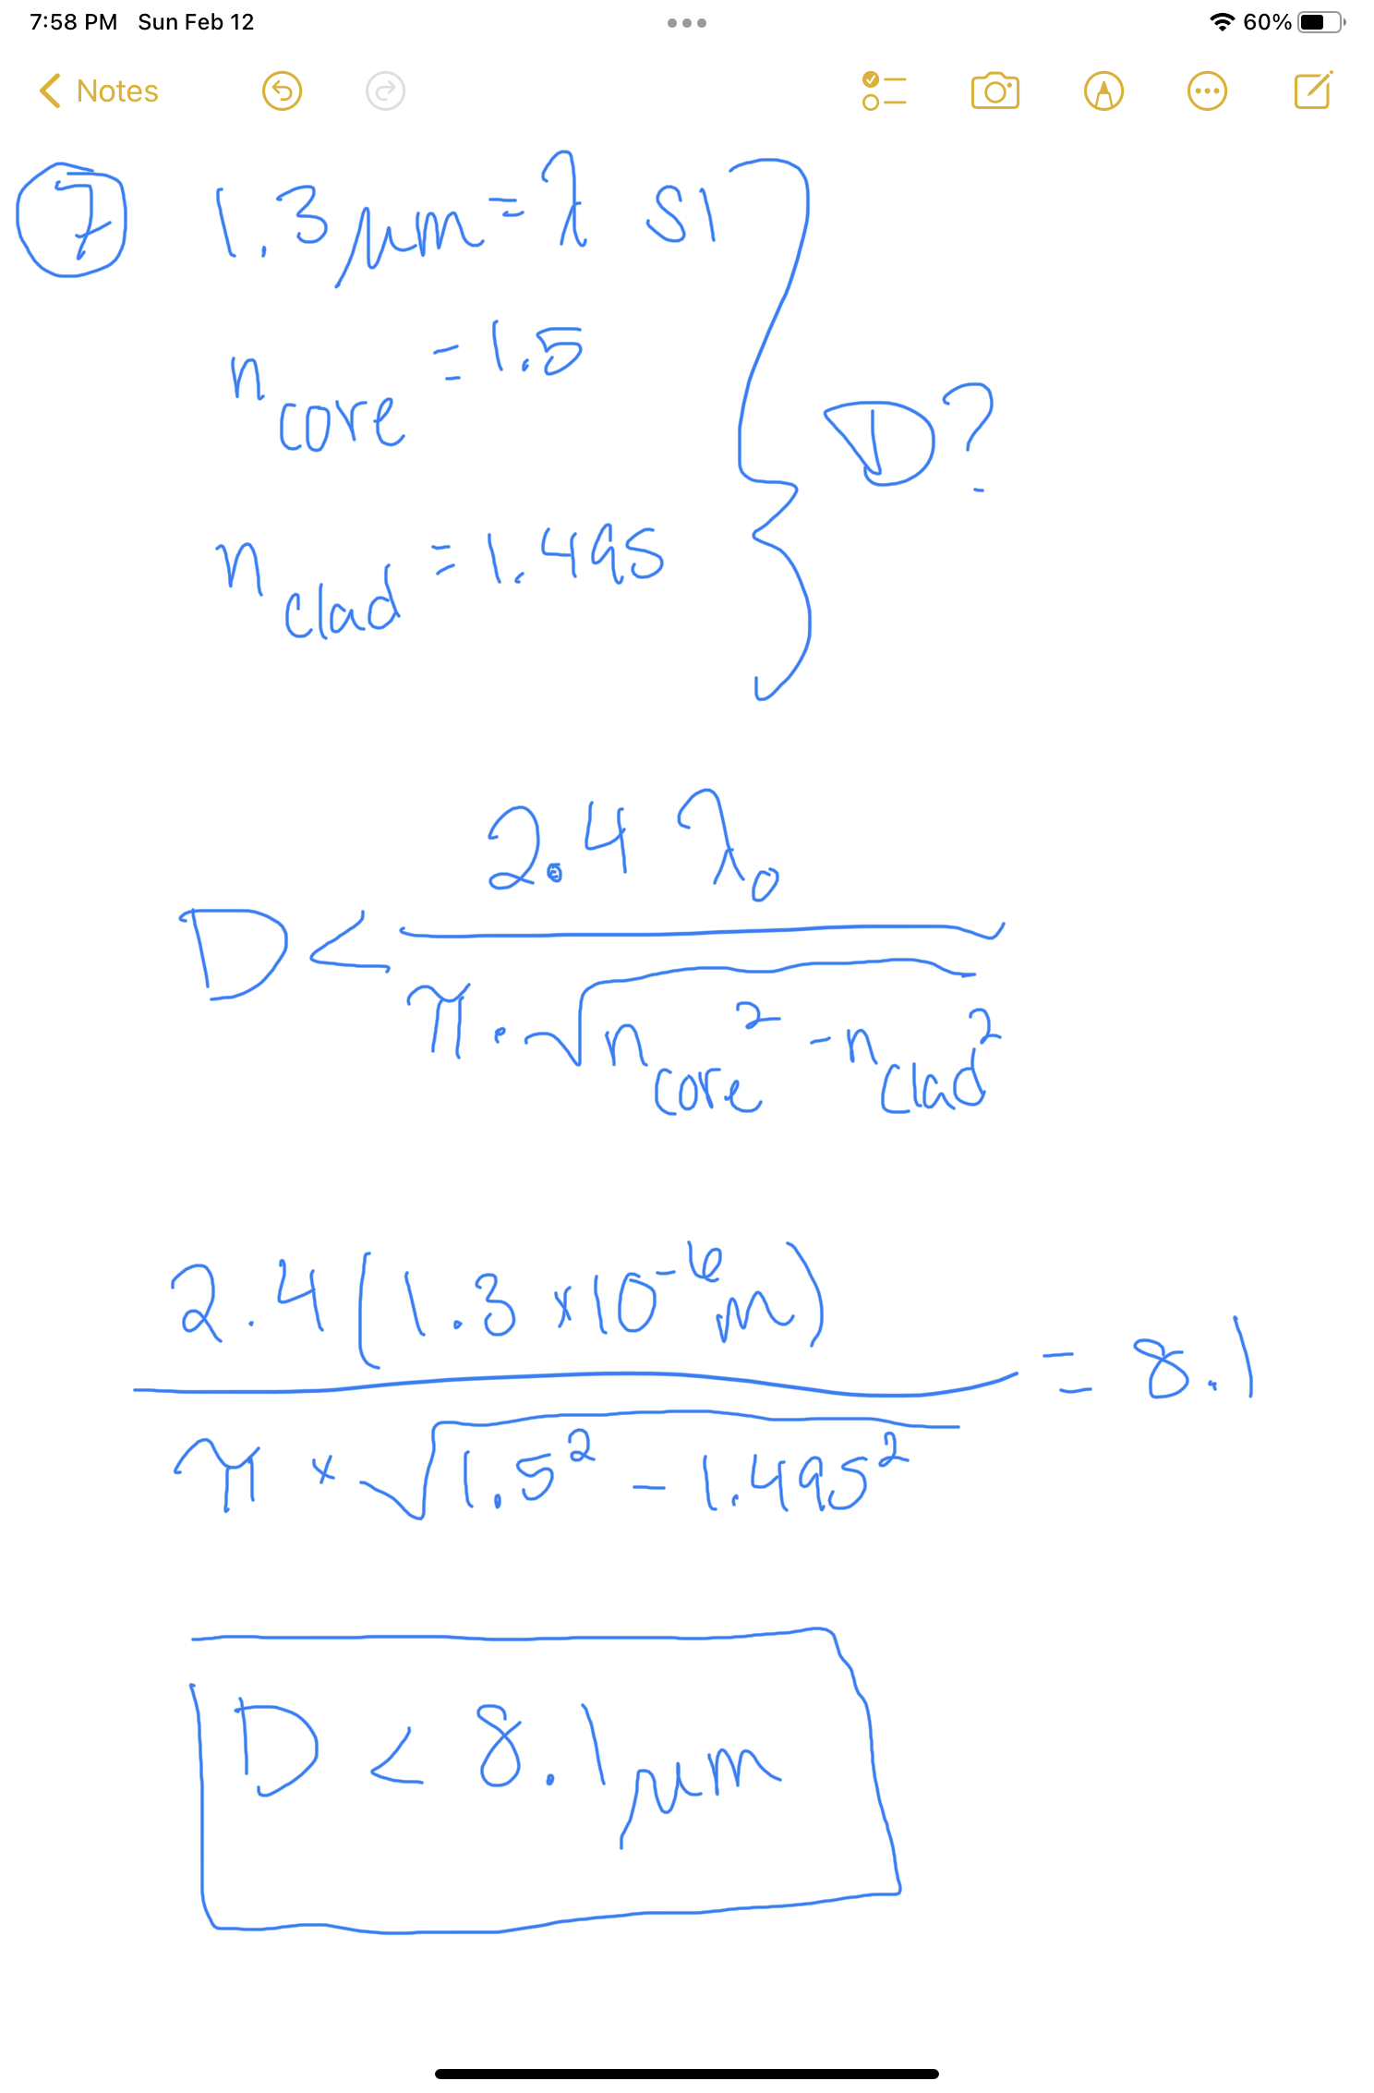
8. What is the cutoff wavelength of a single-mode step-index fiber with core diameter
of 8 micrometers, core index of 1.5 and cladding index of 1.495?
- 0.89 micrometers
- 1.15 micrometers
- 1.28 micrometers
- 1.31 micrometers
- 1.495 micrometers
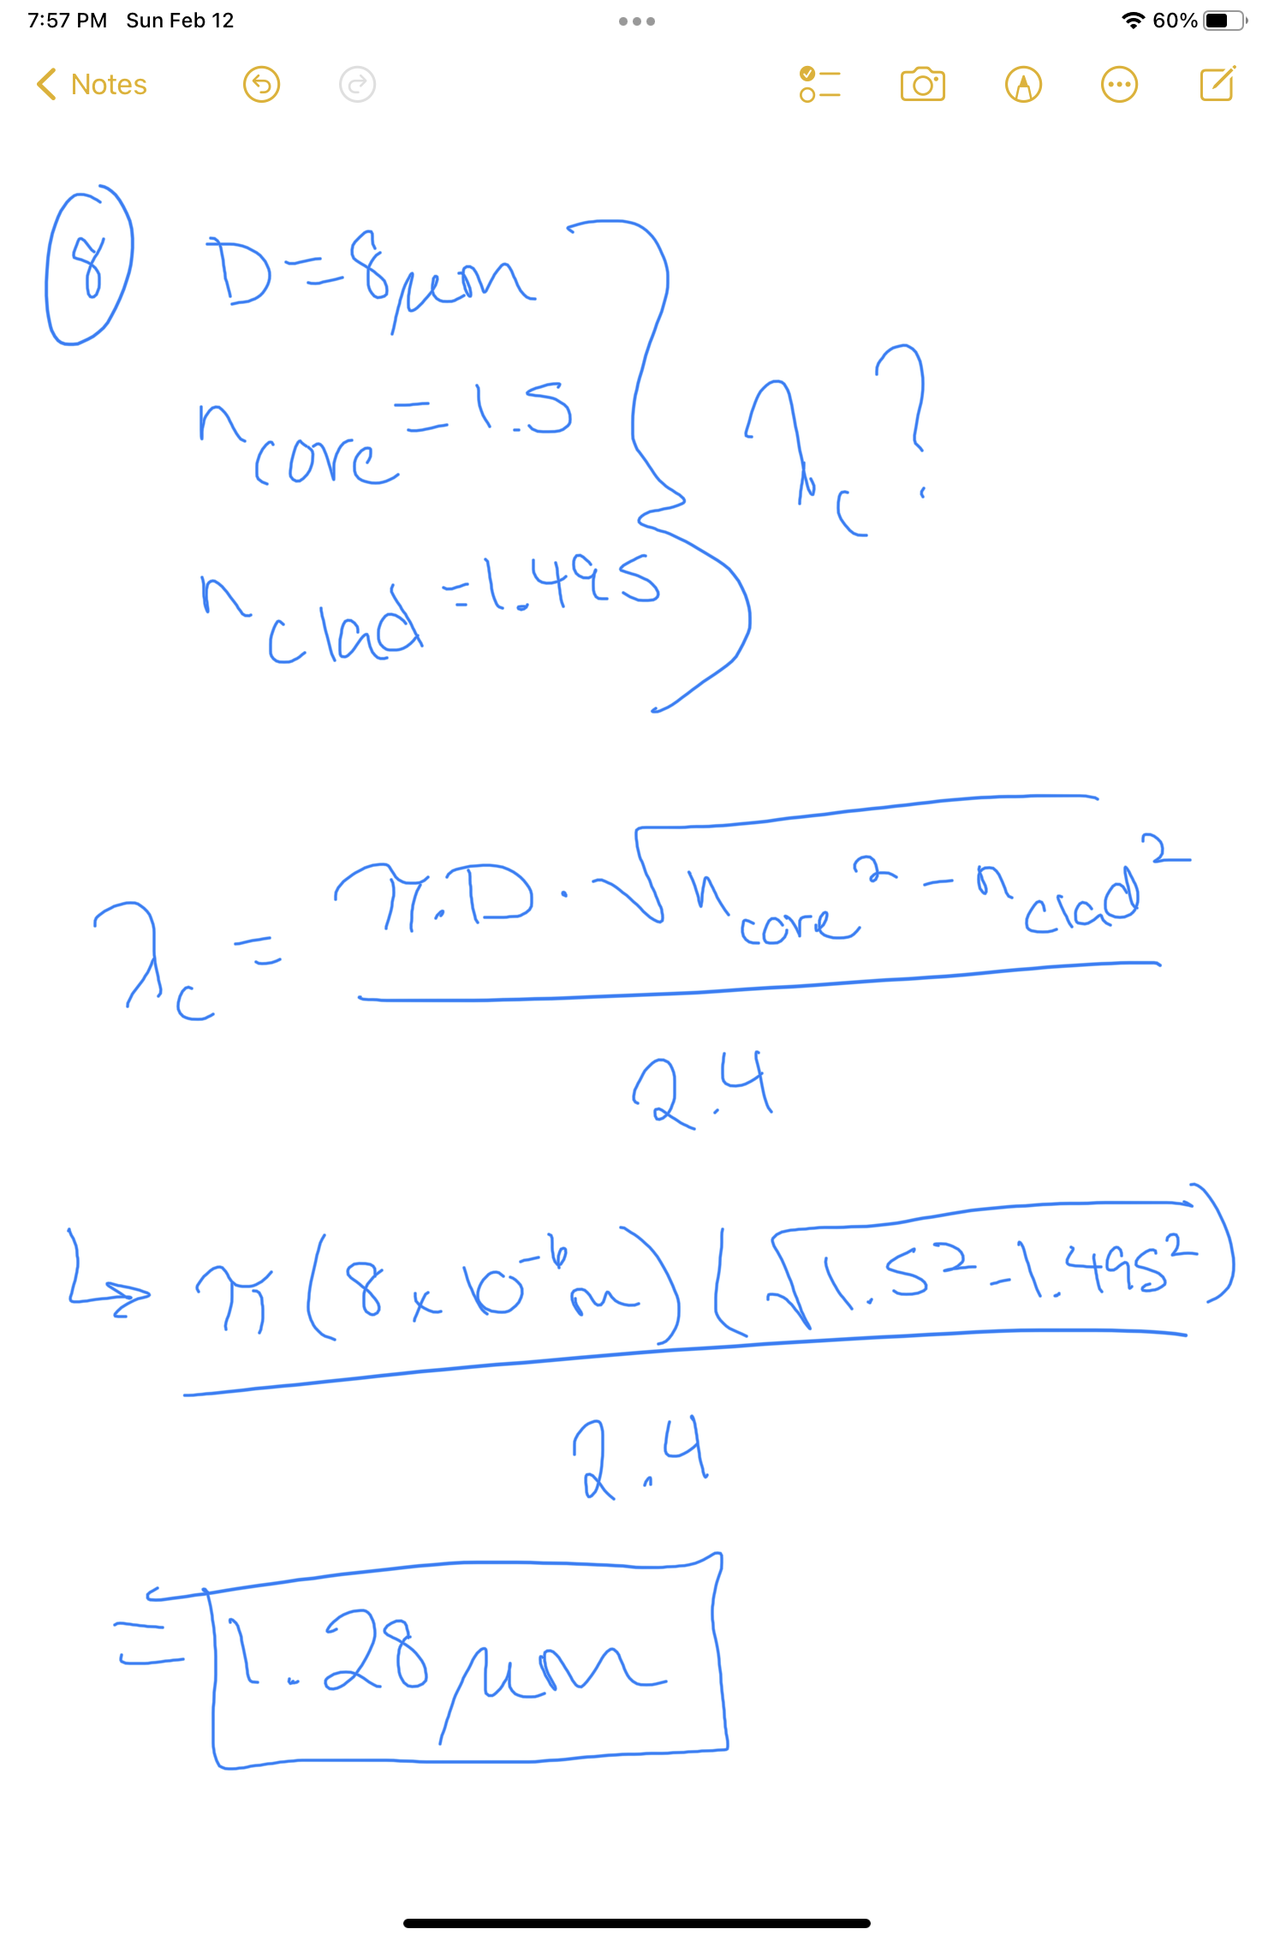
9. What is the cutoff wavelength of a single-mode step-index fiber with core diameter
of 8 micrometers, core index of 1.5 and cladding index of 1.496?
- 0.89 micrometers
- 1.15 micrometers
- 1.28 micrometers
- 1.31 micrometers
- 1.495 micrometers
